**RUBIO GARCIA RODRIGO.**

**CARLOS ENRIQUE MORAN GARABITO.**

**CINEMATICA DE ROBOTS.**

**TAREA 5.**

**8/A MECATRONICA.**

**UPZMG.**



**OBTENER EL D-H Y T0-3 DE LOS SIGUIENTES ROBOTS.**

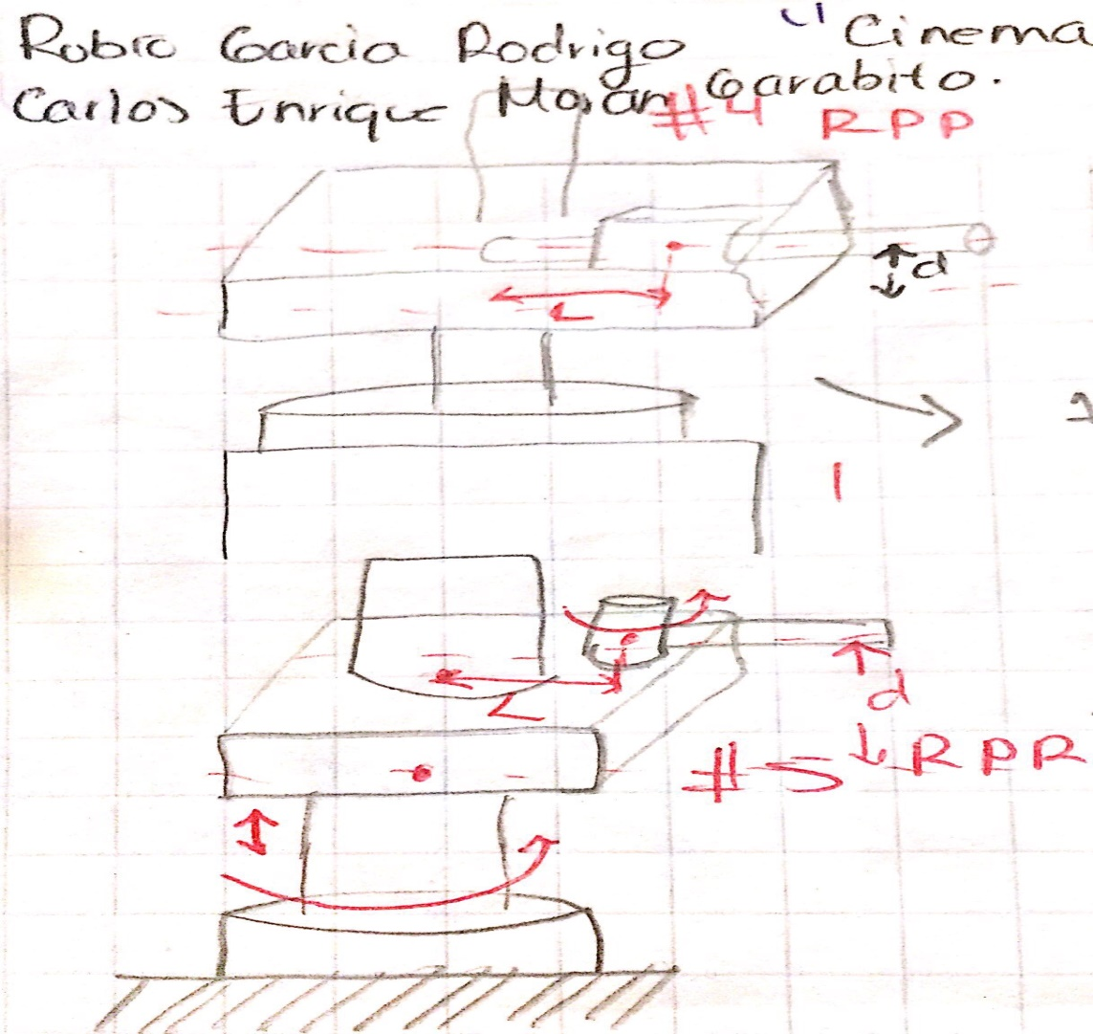

|  |  |  |  |  |
| --- | --- | --- | --- | --- |
| **Eslabón** | **ai-1** | **αi-1** | **di** | **θi** |
| **1** | **0** | **0** | **0** | **Θ1** |
| **2** | **0** | **90°** | **d1** | **Θ2** |
| **3** | **l1** | **0** | **d2** | **Θ3** |

Cos1 -Sen1 0 0 cos2 sen2 0 0 Cos3 Sen3 0 l3

0 0 0 0 sen2 cos2 0 0 Sen3 Cos3 0 0

Sen cos1 0 0 0 0 0 d1 0 0 0 d2

0 0 0 1 0 0 0 1 0 0 0 1

-Cos,Sen2,Sen3 –Cos2,Cos3 Sen,Sen2,Sen3-Cos2,Cos3 0 l

Cos,Sen2,Sen3 +Cos3,Sen – Sen,Cos2,Sen3+ Cos3,Sen2 0 0

Sen Cos 0 d2

0 0 0 1

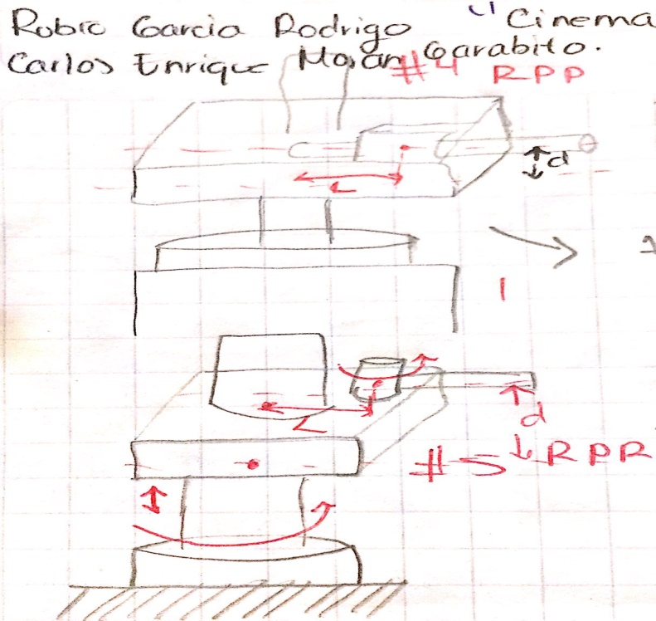

|  |  |  |  |  |
| --- | --- | --- | --- | --- |
| **Eslabón** | **ai-1** | **αi-1** | **di** | **θi** |
| **1** | **0** | **0** | **0** | **Θ1** |
| **2** | **0** | **90°** | **d1** | **Θ2** |
| **3** | **l1** | **90°** | **d2** | **Θ3** |

Cos1 -Sen1 0 0 cos2 sen2 0 0 Cos3 Sen3 0 l1

0 0 0 0 sen2 cos2 0 0 Sen3 Cos3 0 0

Sen cos1 0 0 0 0 0 d2 0 0 0 d2

0 0 0 1 0 0 0 1 0 0 0 1

-Cos,Sen2,Sen3 –Cos2,Cos3 Sen,Sen2,Sen3-Cos2,Cos3 0 l

Cos,Sen2,Sen3 +Cos3,Sen2 – Sen,Cos2,Sen3+ Cos3,Sen2 0 0

Sen Cos 0 d1+d2

0 0 0 1

